Algorithm for File Updates in Python

Project Description
This project demonstrates how Python can be used to update an allow list by opening a file, reading its contents, converting the data to a list, removing unwanted IP addresses, and writing the updated list back to the file. It applies file handling, iteration, conditionals, and list manipulation to manage security-related data.

Open the file that contains the allow list
To open the file, assign the file name to the variable import_file. Then use the with statement along with the open() function to safely open the file. The file object is stored in the variable file.

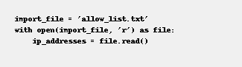

Read the file contents
Use the .read() method to convert the file contents into a string and store it in the ip_addresses variable.

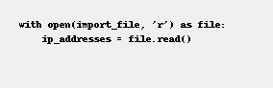

Convert the string into a list
Use the .split() method to convert the string of IP addresses into a list for easier processing.

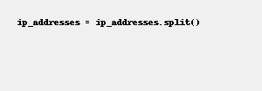

Iterate through the remove list
Set up a for loop to iterate through the remove_list. Use element as the loop variable.
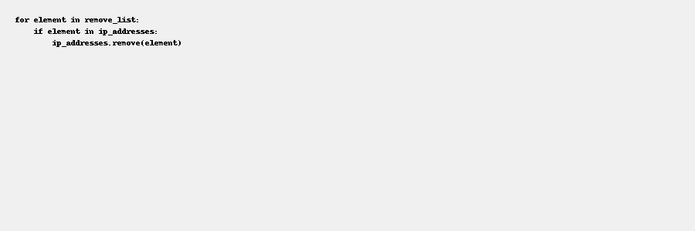

Remove IP addresses that are on the remove list
Inside the loop, check whether the element exists in the ip_addresses list. If it does, remove it using the .remove() method. This works safely because there are no duplicates in the allow list.

Update the file with the revised list of IP addresses
Convert the list back into a string using the .join() method. Then open the file again using a with statement in write mode and overwrite the file with the updated list.

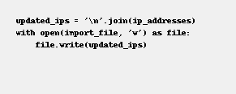

Summary
This algorithm demonstrates key Python skills including file handling with open(), reading using .read(), list manipulation with .split() and .remove(), iteration with for loops, and file writing with .write(). It efficiently updates an allow list by removing unwanted entries and saving the revised version.

